Header

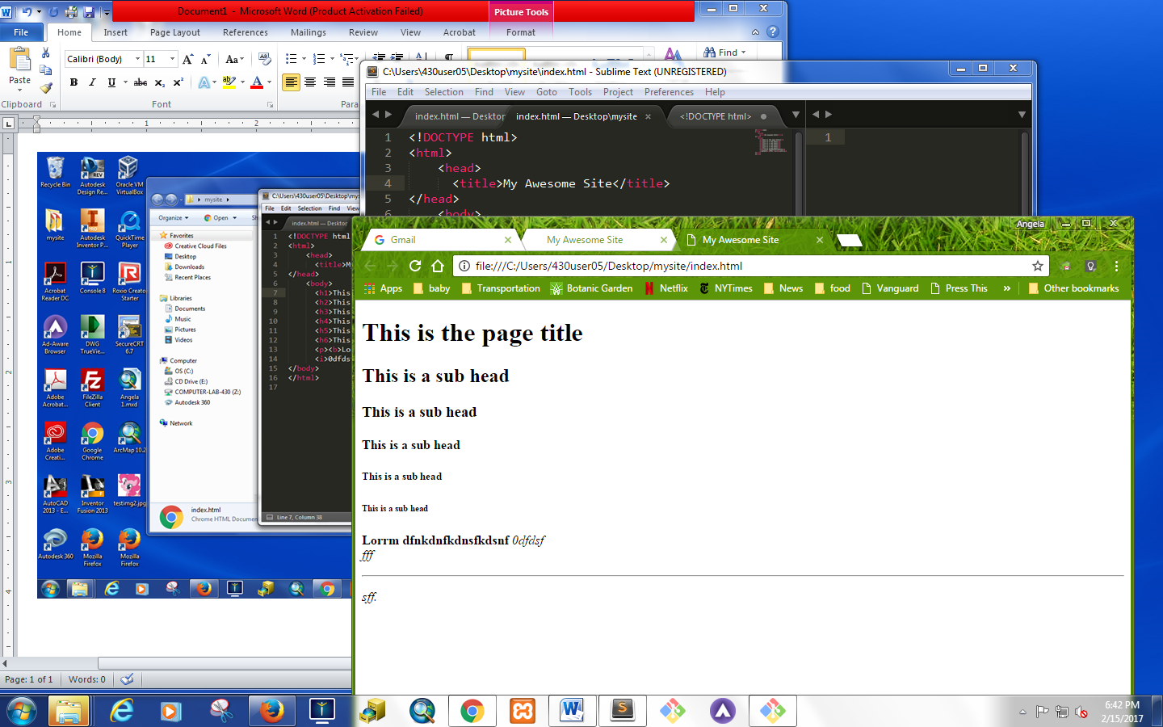

Body Text

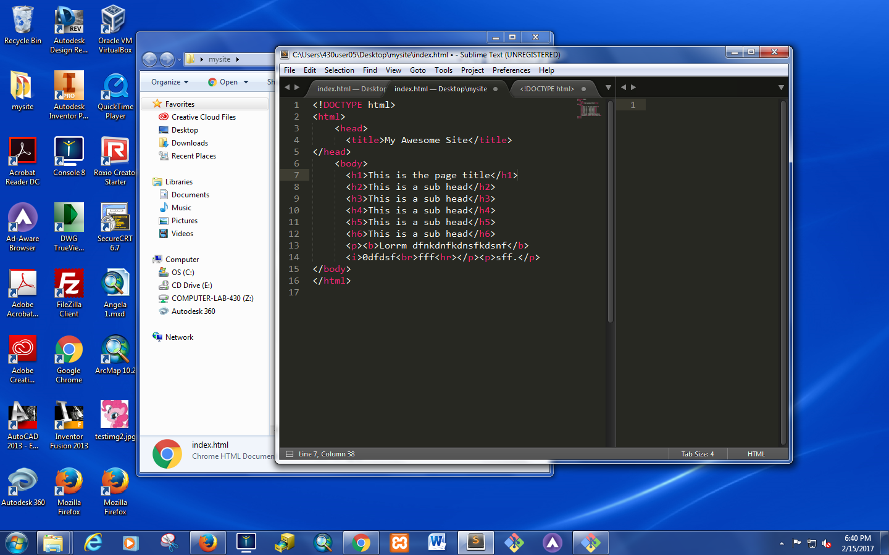

Html has 6 headers

H1 used for titles

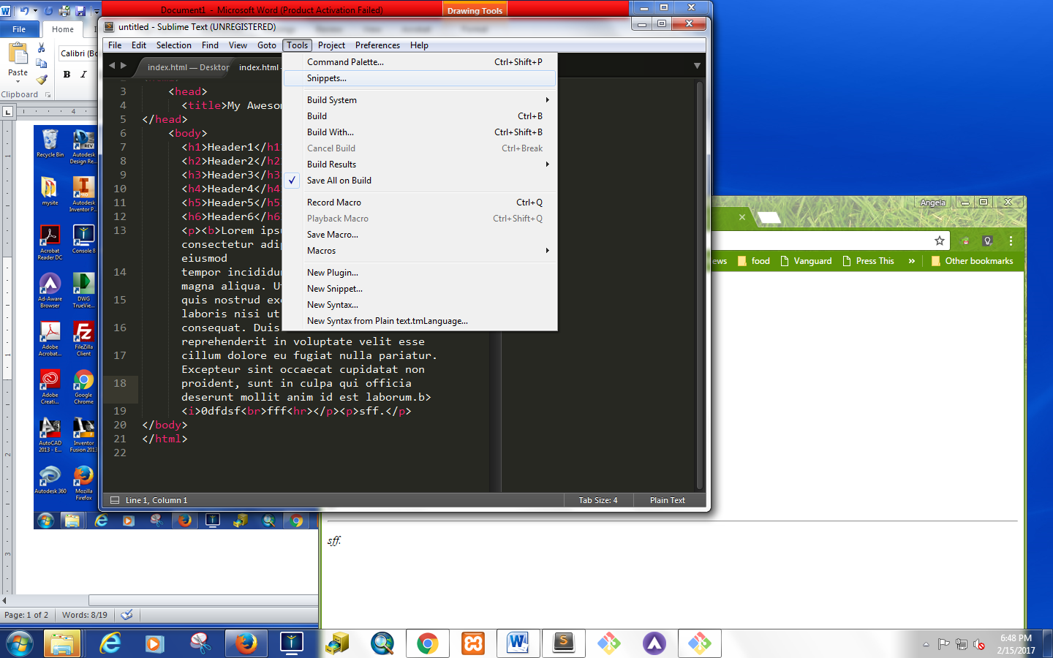

Lorem ipsum

* **Line break = one line <br>**
* **Paragraph = double space <p>**
* **Horizontal rule = horizontal line = <hr>**
* **Difference between relative paths = path to file that exist in route directory i.e. (relative to the document you are working off of)**
* **Absolute path starts with https or http (click copy image address)**
* **<a> = is used for links**
* **Open as a separate tab (enter information as “target")**
  + **<a href="https://www.facebook.com/beyonce/" target="_blank">Bey's fb </a>**

**<ol>**

**<li> thing A </li>**

**<li> thing B </li>**

**</ol>**

**<ul>**

**<li> stuff A </li>**

**<li> stuff B </li>**

**</ul>**

1. *thing A*
2. *thing B*

* *stuff A*
* *stuff B*

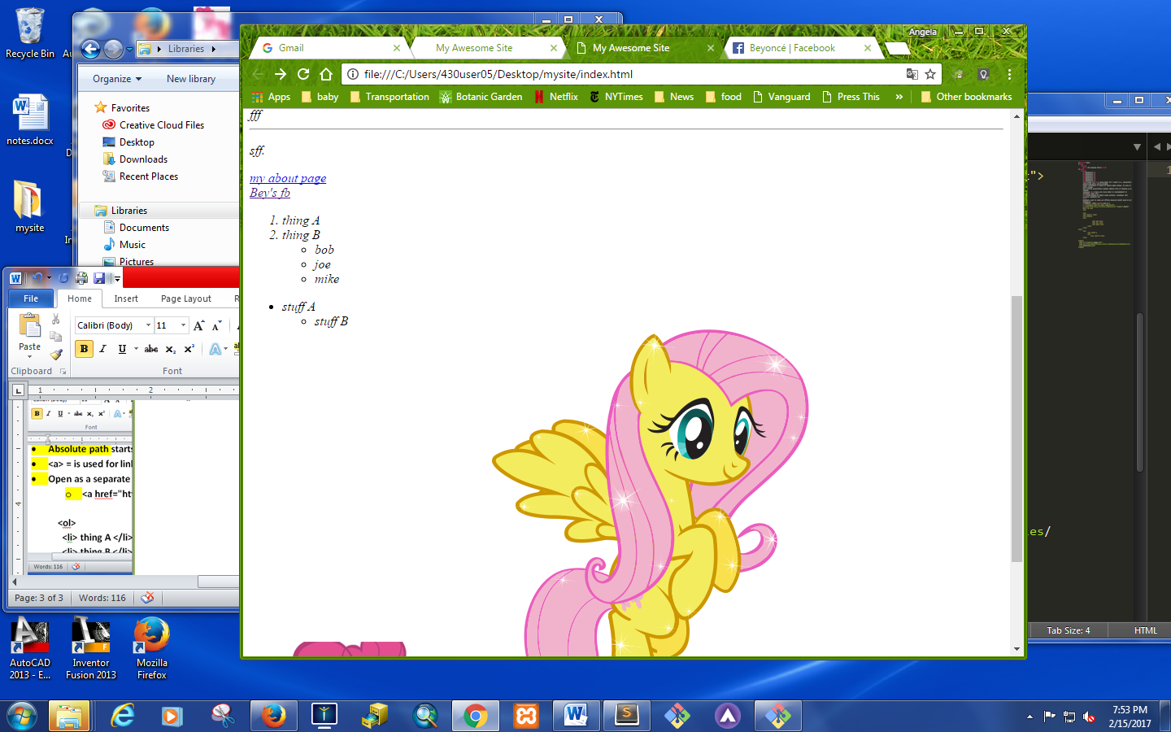   

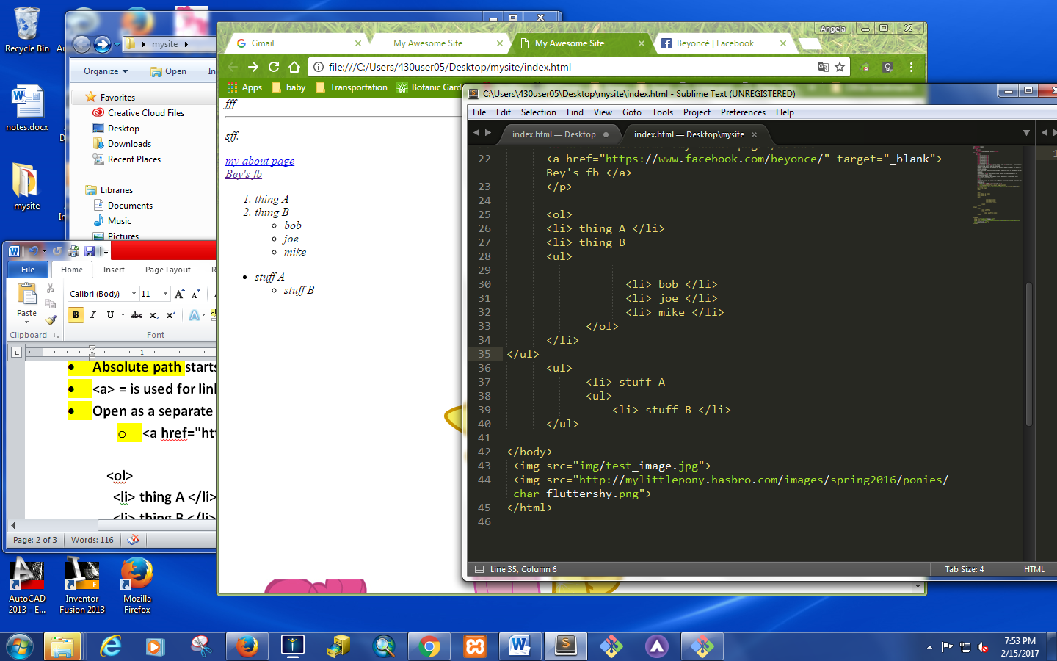

opoip

**<iframe width="560" height="315" src="https://www.youtube.com/embed/sOnqjkJTMaA?rel=0" frameborder="0" allowfullscreen></iframe>**

**HTML Input Types:**

[**https://www.w3schools.com/html/html_form_input_types.asp**](https://www.w3schools.com/html/html_form_input_types.asp)

**html notes:**

1. **attributes are followed by = and a value**
2. **soft return: <br>**
3. **hard return: <p>**
4. **<br> and <p> are examples of elements**
5. **<ol> orderd list**

**<li> list items**

**6. <ul> unordered list**

**<li> list items**

**7. to create link: <a href= “about.html”>**

1. **to create link ina new tab: <a href= “about.html” target=_blank>**

**2. Only use absolute links for sites you can’t control**

**3. black quote to create callouts**

**4. Div’s are boxes - a. header b. footer c. nav (created so people can identify easily what the element is)**

**5. comment command in html :: <!--insert comment -->**

**6. section>> article >> side**

**7. special character: &copy ; &trade; &registration**

**8. non breaking spaces:**

**9. link within a page >> <div id=landing>**

**<a href=#landing">**

**10. html >> forms >> label and inputs**

**11. radio buttons and checkboxes – all have to have the same “name”**

**12. to add in required fields – add in “required” before the “>”**

**13.**

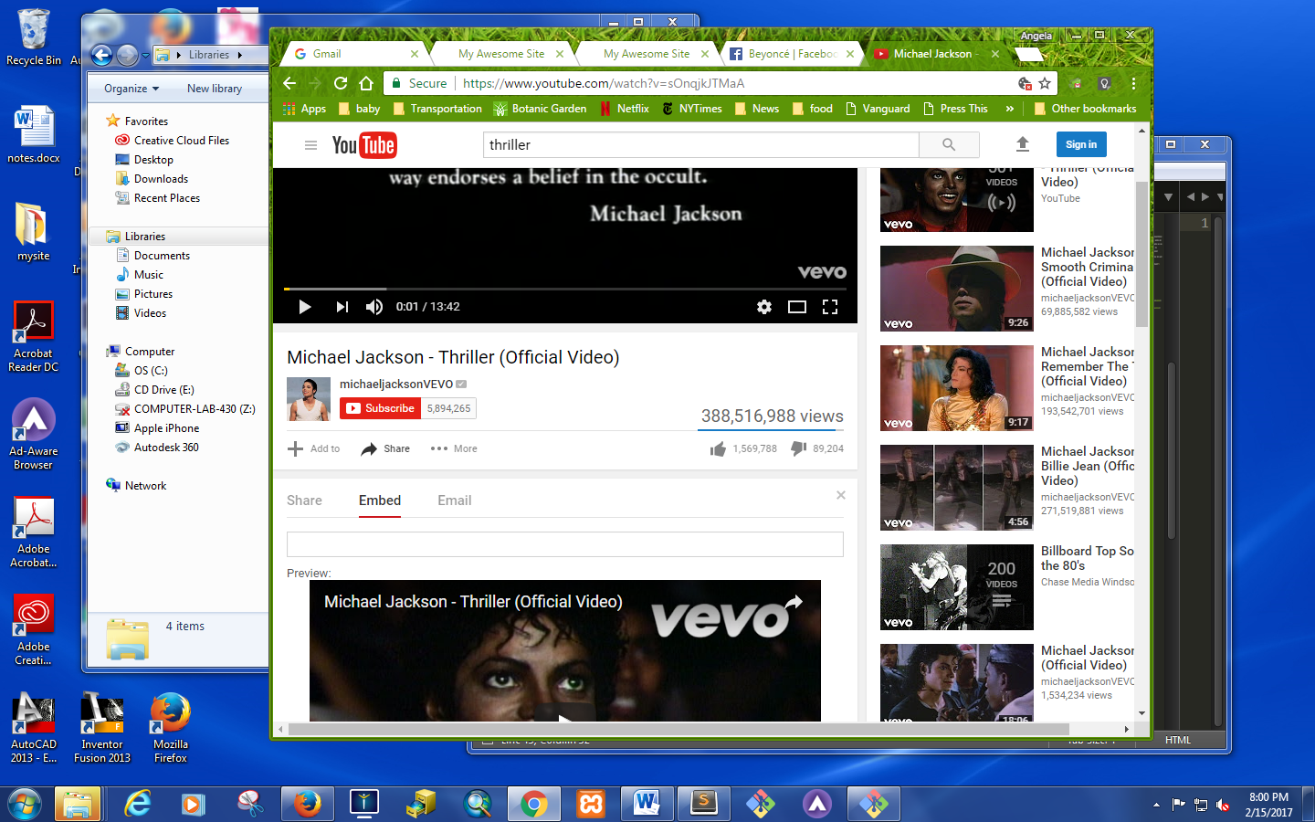

**Git Commands:**

*Create directory*:

* Make directory – mk dir titlefolder
* Cd titlefolder
* Touch index.html about.html contact.html
* Mk dir css img js

*Create Repository:*

Start of the project git init to initialize

1. cd ~/desktop/mysite

2. git init

3. git status

4. git add . (staging to commit these files)

5. git status

6. **git commit -m "create contact pg"** (you can have multiple commits)

7. git status

8. git log (to check all commits ever created)

9. git push https://github.com/amartinez770/mycoolproject.git master (master to specify master branch)

10. git ls (list all commits)

11. mv about.html aboutus.html (to change name of a file)

12. rm dir “makeofdir” (remove content with no content inside)

13. touch css/style.css (to create a style sheet within the css directory)

14. rm dir –r “name of directory” (remove dir with content with in)

15. mk dir

16. touch my\file.html (name of directory with a space put in a “\”)

17. cd .. (to go up a dir)

18. cd title folder/ (**to clone/copy a file**)

19. git checkout –b branchname **(to create a branch)**

Rm index2.html

git add .

git commit –m “cleanup”

20. git checkout master

21.git merge branchname

22. git config –-global user.name (create user.name)

23. git config –-global user.name “Antoinette.Martinez

24. git log (to get commit ID)

25. git reset –-hard commit ID (to reset)

26. git status

27. git push url-link master (push our info to our link repository and the file to push)

To clone folder

28. cd ..

29. git clone url

30. mk dir clones

31. cd clone

32. cd ..

33. git pull url

34. cd title/folder

35. pull url

36. git pull

Add login info

If error message “remove previous git credentials” by entering credentials to windows search

git clone <https://github.com/amartinez770/mycoolproject.git> (to create duplicative folder)

**Git repositories:**

430user05@H430-BITC05 MINGW64 ~

$ cd~desktop/mysite

bash: cd~desktop/mysite: No such file or directory

430user05@H430-BITC05 MINGW64 ~

$ git status

fatal: Not a git repository (or any of the parent directories): .git

430user05@H430-BITC05 MINGW64 ~

$ cd ~desktop/mysite

bash: cd: ~desktop/mysite: No such file or directory

430user05@H430-BITC05 MINGW64 ~

$ cd ~/desktop/mysite

430user05@H430-BITC05 MINGW64 ~/desktop/mysite (master)

$ git status

On branch master

nothing to commit, working directory clean

430user05@H430-BITC05 MINGW64 ~/desktop/mysite (master)

$ git add.

git: 'add.' is not a git command. See 'git --help'.

Did you mean this?

add

430user05@H430-BITC05 MINGW64 ~/desktop/mysite (master)

$ git add .

430user05@H430-BITC05 MINGW64 ~/desktop/mysite (master)

$ git status

On branch master

nothing to commit, working directory clean

430user05@H430-BITC05 MINGW64 ~/desktop/mysite (master)

$ git commit -m "create contact page"

On branch master

nothing to commit, working directory clean

430user05@H430-BITC05 MINGW64 ~/desktop/mysite (master)

$ git commit -m "vreate contact pg"

On branch master

nothing to commit, working directory clean

430user05@H430-BITC05 MINGW64 ~/desktop/mysite (master)

$ git status

On branch master

nothing to commit, working directory clean

430user05@H430-BITC05 MINGW64 ~/desktop/mysite (master)

$ git commit -m "vreate contact pg"

On branch master

nothing to commit, working directory clean

430user05@H430-BITC05 MINGW64 ~/desktop/mysite (master)

$ git commit -m "create contact pg"

On branch master

nothing to commit, working directory clean

430user05@H430-BITC05 MINGW64 ~/desktop/mysite (master)

$ git push https://github.com/amartinez770/mycoolproject.git master

remote: Permission to amartinez770/mycoolproject.git denied to wemui609.

fatal: unable to access 'https://github.com/amartinez770/mycoolproject.git/': Th e requested URL returned error: 403

430user05@H430-BITC05 MINGW64 ~/desktop/mysite (master)

$ git push https://github.com/amartinez770/mycoolproject.git master

remote: Permission to amartinez770/mycoolproject.git denied to wemui609.

fatal: unable to access 'https://github.com/amartinez770/mycoolproject.git/': The requested URL returned err or: 403

430user05@H430-BITC05 MINGW64 ~/desktop/mysite (master)

$ git push https://github.com/amartinez770/mycoolproject.git master

Counting objects: 10, done.

Delta compression using up to 8 threads.

Compressing objects: 100% (8/8), done.

Writing objects: 100% (10/10), 2.98 MiB | 1.32 MiB/s, done.

Total 10 (delta 1), reused 0 (delta 0)

remote: Resolving deltas: 100% (1/1), done.

To https://github.com/amartinez770/mycoolproject.git

* [new branch] master -> master

430user05@H430-BITC05 MINGW64 ~/desktop/mysite (master)

$ git clone

You must specify a repository to clone.

usage: git clone [<options>] [--] <repo> [<dir>]

-v, --verbose be more verbose

-q, --quiet be more quiet

--progress force progress reporting

-n, --no-checkout don't create a checkout

--bare create a bare repository

--mirror create a mirror repository (implies bare)

-l, --local to clone from a local repository

--no-hardlinks don't use local hardlinks, always copy

-s, --shared setup as shared repository

--recursive initialize submodules in the clone

--recurse-submodules initialize submodules in the clone

--template <template-directory>

directory from which templates will be used

--reference <repo> reference repository

--dissociate use --reference only while cloning

-o, --origin <name> use <name> instead of 'origin' to track upstream

-b, --branch <branch>

checkout <branch> instead of the remote's HEAD

-u, --upload-pack <path>

path to git-upload-pack on the remote

--depth <depth> create a shallow clone of that depth

--single-branch clone only one branch, HEAD or --branch

--separate-git-dir <gitdir>

separate git dir from working tree

-c, --config <key=value>

set config inside the new repository

-4, --ipv4 use IPv4 addresses only

-6, --ipv6 use IPv6 addresses only

430user05@H430-BITC05 MINGW64 ~/desktop/mysite (master)

$ git clone https://github.com/amartinez770/mycoolproject.git

Cloning into 'mycoolproject'...

remote: Counting objects: 10, done.

remote: Compressing objects: 100% (7/7), done.

remote: Total 10 (delta 1), reused 10 (delta 1), pack-reused 0

Unpacking objects: 100% (10/10), done.

Checking connectivity... done.

430user05@H430-BITC05 MINGW64 ~/desktop/mysite (master)

$ git log

commit ed15bedf3d7148cbe3decfe94f176490e523bee8

Author: antoinette.martinez <martinez.antoinette@gmail.com>

Date: Wed Feb 22 21:06:58 2017 -0500

starting git

430user05@H430-BITC05 MINGW64 ~/desktop/mysite (master)

$

430user05@H430-BITC05 MINGW64 ~/desktop/mysite (master)

$

430user05@H430-BITC05 MINGW64 ~/desktop/mysite (master)

$

430user05@H430-BITC05 MINGW64 ~/desktop/mysite (master)

$ 430user05@H430-BITC05 MINGW64 ~/desktop/mysite (master)

bash: syntax error near unexpected token `('

430user05@H430-BITC05 MINGW64 ~/desktop/mysite (master)

$ $

bash: $: command not found

430user05@H430-BITC05 MINGW64 ~/desktop/mysite (master)

$

430user05@H430-BITC05 MINGW64 ~/desktop/mysite (master)

$

430user05@H430-BITC05 MINGW64 ~/desktop/mysite (master)

$

430user05@H430-BITC05 MINGW64 ~/desktop/mysite (master)

$

430user05@H430-BITC05 MINGW64 ~/desktop/mysite (master)

$ 430user05@H430-BITC05 MINGW64 ~/desktop/mysite (master)

bash: syntax error near unexpected token `('

430user05@H430-BITC05 MINGW64 ~/desktop/mysite (master)

$ $

bash: $: command not found

430user05@H430-BITC05 MINGW64 ~/desktop/mysite (master)

$

430user05@H430-BITC05 MINGW64 ~/desktop/mysite (master)

$

430user05@H430-BITC05 MINGW64 ~/desktop/mysite (master)

$

430user05@H430-BITC05 MINGW64 ~/desktop/mysite (master)

$ 430user05@H430-BITC05 MINGW64 ~/desktop/mysite (master)

bash: syntax error near unexpected token `('

430user05@H430-BITC05 MINGW64 ~/desktop/mysite (master)

$ $

bash: $: command not found

430user05@H430-BITC05 MINGW64 ~/desktop/mysite (master)

$

430user05@H430-BITC05 MINGW64 ~/desktop/mysite (master)

$

430user05@H430-BITC05 MINGW64 ~/desktop/mysite (master)

$ 430user05@H430-BITC05 MINGW64 ~/desktop/mysite (master)

bash: syntax error near unexpected token `('

430user05@H430-BITC05 MINGW64 ~/desktop/mysite (master)

$ $

bash: $: command not found

430user05@H430-BITC05 MINGW64 ~/desktop/mysite (master)

$ ^C

430user05@H430-BITC05 MINGW64 ~/desktop/mysite (master)

$

**CSS Notes:**

1. color:rgb(85, 26, 139);
2. cursor:auto;
3. display:inline;
4. font-family:helevetica;
5. font-size:55px;
6. font-weight:bold;
7. height:auto;
8. letter-spacing:200px;
9. line-height:82.5px;
10. text-align:center;
11. text-decoration:underline;
12. text-transform:uppercase;
13. width:auto;

**CSS:**

**Background –**

**body {**

**padding: 40px;**

**background-color: #9BDEFB;**

**background-image: url(**[**http://weknowyourdreams.com/ocean.html**](http://weknowyourdreams.com/ocean.html)**);**

**background-size: contain;**

**background position: center center;**

**}**

**Specify css style by**

* **tag name**
* **ID “#” is needed**
* **class “.” Is needed**

**<p> are only inbetween div’s**

**Specify attribute by class name + ID**

**Parent and child relationships**

**Sibling relationship .group + example**